

SELF SERVICE FOOD KIOSK IN RESTAURANT

Group 2

Names : Ishom Nabil Umran Alihaq

Muhammad Ervin Fadillah

Rico Mesias Tamba

Class : 1CC2

CEP CCIT

FAKULTAS TEKNIK UNIVERSITAS INDONESIA

2022

**PROJECT ON**

*Self Service Food Kiosk on Restaurant*

**Developed by**

1. **Ishom Nabil Umran Alihaq**
2. **Muhammad Ervin Fadillah**
3. **Rico Mesias Tamba**



**Self Service Food Kiosk on Restaurant**

Batch Code : 1CC2

Start Date : 19 October 2022   
End Date : 2 November 2022

Name of Faculty : Aisah Rini

Names of Developer :

1. Ishom Nabil Umran Alihaq
2. Muhammad Ervin Fadillah
3. Rico Mesias Tamba

Date of Submission: 1 November 2022

**CERTIFICATE**

This is to certify that this report titled “Self Service Food Kiosk In Restaurant” embodies the original work done by Ishom Nabil Umran Alihaq, Muhammad Ervin Fadillah, and Rico Mesias Tamba. Project in partial fulfillment of their course requirement at NIIT.

Coordinator:

Aisah Rini



**ACKNOWLEDGEMENT**

First, we would like to thank God the Almighty, who has given his bless to the author for finishing these papers, second, we would like to thank all parties who have helped in the process of completing these papers, especially Ms Aisah Rini as the faculty. Although this paper is not yet perfect, we hope that these papers can be used deepen the understanding about the Self Service Food Kiosk in Restaurant.

Depok, October 2022

Authors

**SYSTEM ANALYSIS**

**System Summary:**

Self Service Food Kiosk is a technology where the customer make orders from the kiosk and the order will be sent to the order queue system after the customer pay their order using between cash or credit card.

**System Process:**

Self Service Food Kiosk is a program for taking orders from customer, after that the order will be sent to the order queue in the kitchen computer, then the employees will process the order you make.

**FLOWCHART**

**MAIN PROGRAM**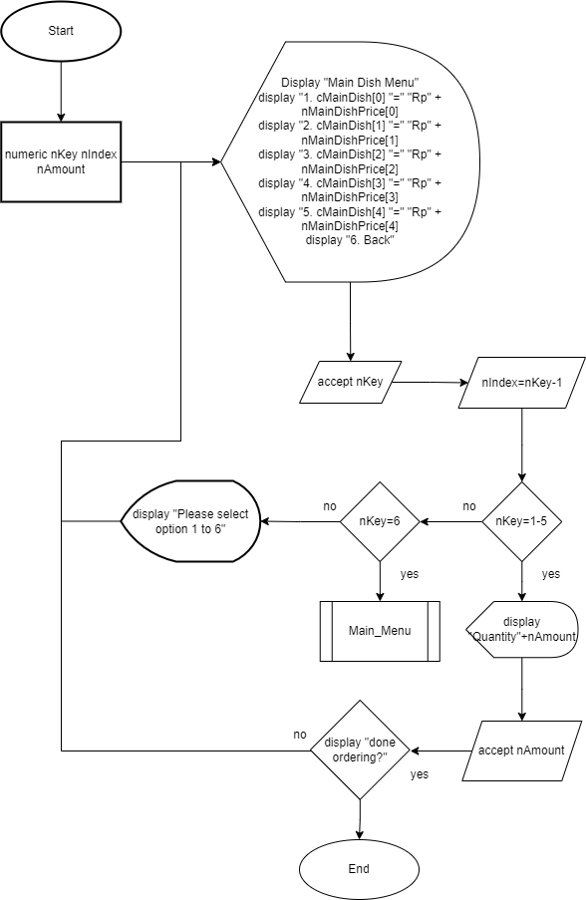

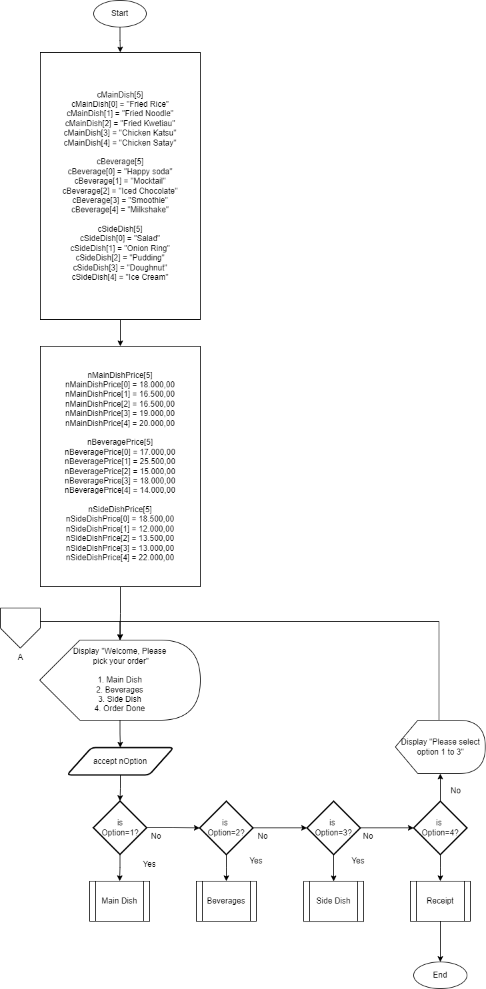



**FLOWCHART**

**MAIN DISH**

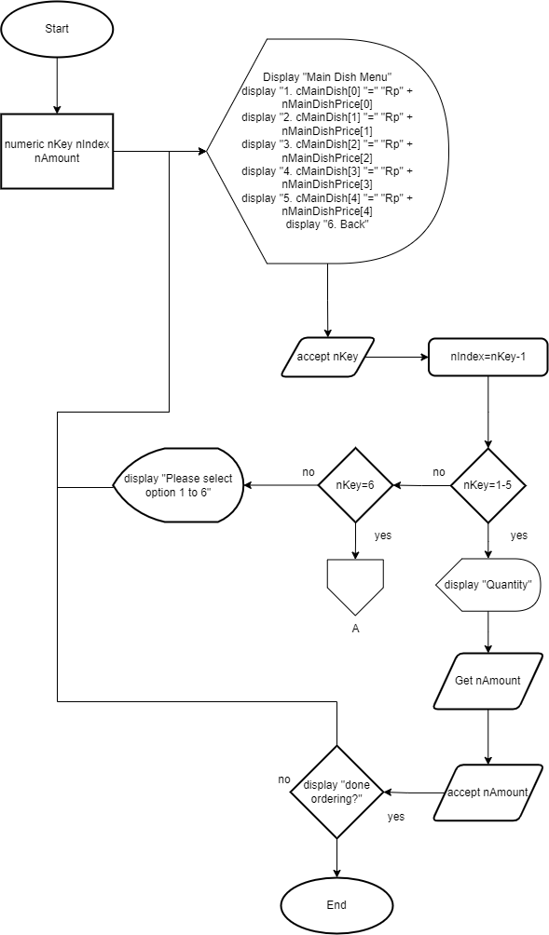

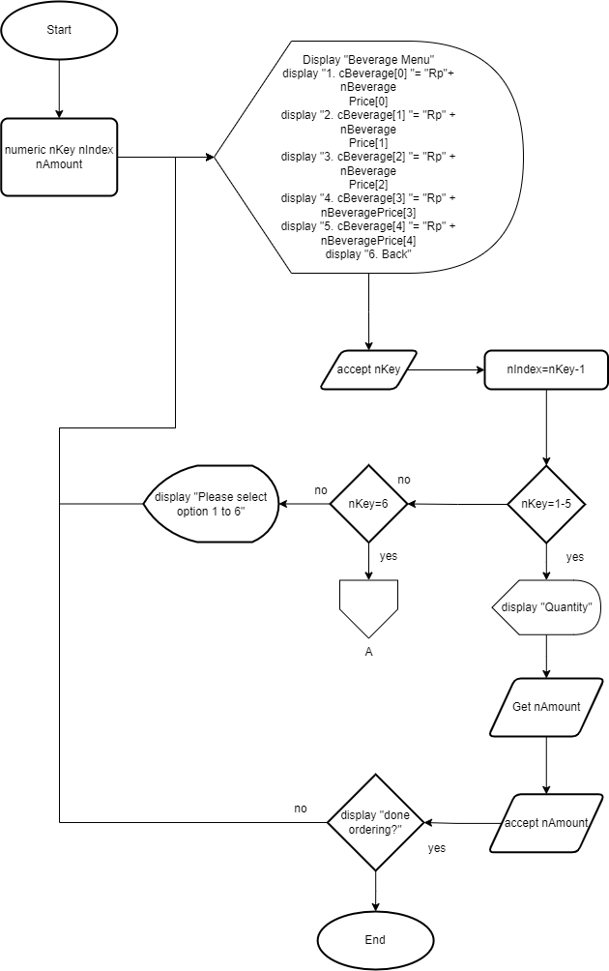

**FLOWCHART**

**BEVERAGE**

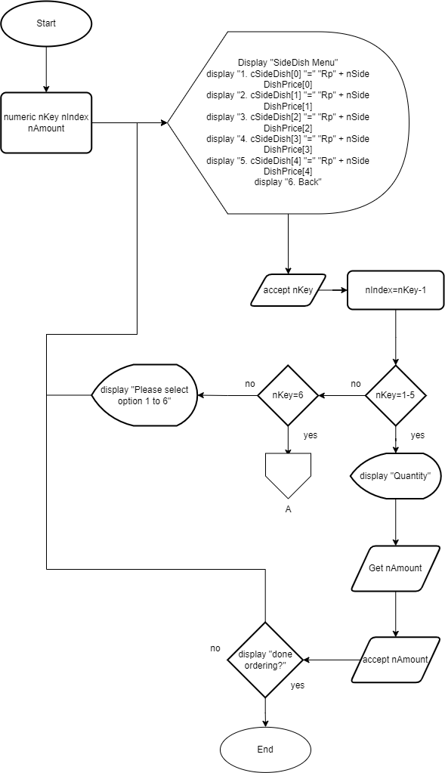

**FLOWCHART**

**SIDE DISH**

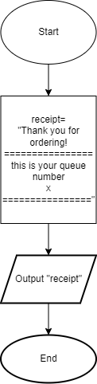

**FLOWCHART**

**Receipt**

**PSEUDOCODE**

**Main Menu**

begin

Character cMainDish[5], cBeverage[5], cSideDish[5]

Numeric nMainDishPrice[5], nBeveragePrice[5], nSideDishPrice[5]

cMainDish[0] = "Fried Rice"

cMainDish[1] = "Fried Noodle"

cMainDish[2] = "Fried Kwetiau"

cMainDish[3] = "Chicken Katsu"

cMainDish[4] = "Chicken Satay"

cBeverage[0] = "Happy Soda"

cBeverage[1] = "Mocktail"

cBeverage[2] = "Iced Chocolate"

cBeverage[3] = "Smoothie"

cBeverage[4] = "Milkshake"

cSideDish[0] = "Salad"

cSideDish[1] = "Onion Ring"

cSideDish[2] = "Pudding"

cSideDish[3] = "Doughnut"

cSideDish[4] = "Ice Cream"

nMainDishPrice[0] = 18.000,00

nMainDishPrice[1] = 16.500,00

nMainDishPrice[2] = 16.500,00

nMainDishPrice[3] = 19.000,00

nMainDishPrice[4] = 20.000,00

nBeveragePrice[0] = 17.000,00

nBeveragePrice[1] = 25.500,00

nBeveragePrice[2] = 15.000,00

nBeveragePrice[3] = 18.000,00

nBeveragePrice[4] = 14.000,00

nSideDishPrice[0] = 18.500,00

nSideDishPrice[1] = 12.000,00

nSideDishPrice[2] = 13.500,00

nSideDishPrice[3] = 13.000,00

nSideDishPrice[4] = 22.000,00

// Main Program

Begin

numeric nOption

Main_Menu:

Display "Welcome, Please pick your order"

Display "1. Main Dish"

Display "2. Beverages"

Display "3. Side Dish"

Display "4. Done"

accept nOption

Begin

if (option == 1) then

Call Main_Dish

if else (option == 2) then

Call Beverages

if else (option == 3) then

Call Side_Dish

if else (option == 4)

else

Display "Please select option 1 to 4"

goto Main_Menu

endif

Call Procedure_Receipt

Display "ThankYou for ordering"

end

**PSEUDOCODE**

**Main Dish**

// Procedure Main_Dish

Begin

numeric nKey, nIndex, nAmount

Main_Dish_Menu:

Display "Main Dish Menu"

Display "1. cMainDish[0] "=" Rp "+nMainDishPrice[0]

Display "2. cMainDish[1] "=" Rp "+nMainDishPrice[1]

Display "3. cMainDish[2] "=" Rp "+nMainDishPrice[2]

Display "4. cMainDish[3] "=" Rp "+nMainDishPrice[3]

Display "5. cMainDish[4] "=" Rp "+nMainDishPrice[4]

Display "6. Back To Main Menu"

accept nKey

Begin

Main_Dish_Menu:

nIndex=nKey-1

if (nKey == 6)

then goto Main_Menu

if else (nkey == 1-5)

then Display "quantity"

get nAmount

accept nAmount

else

display "Please select option 1 to 6"

goto Main_Dish_Menu

endif

Begin

get OrderFinish

accept OrderFinish

if (OrderFinish == YES) then

goto Main_Menu

if else (OrderFinish == NO) then

goto Main_Dish_Menu

endif

end

**PSEUDOCODE**

**Beverage**

// Procedure Beverage

Begin

numeric nKey, nIndex, nAmount

Beverage_Menu:

Display "beverages Menu"

Display "1. cBeverages[0] "=" Rp"+nBeveragesPrice[0]

Display "2. cBeverages[1] "=" Rp"+nBeveragesPrice[1]

Display "3. cBeverages[2] "=" Rp"+nBeveragesPrice[2]

Display "4. cBeverages[3] "=" Rp"+nBeveragesPrice[3]

Display "5. cBeverages[4] "=" Rp"+nBeveragesPrice[4]

Display "6. Back To Main Menu"

accept nKey

Begin

Side_Dish_Menu:

nIndex=nKey-1

if (nKey == 6)

then goto Main_Menu

if else (nkey == 1-5)

then Display "quantity"

get nAmount

accept nAmount

else

display "Please select option 1 to 6"

goto Beverage_Menu

endif

Begin

get OrderFinish

accept OrderFinish

if (OrderFinish == YES) then

goto Main_Menu

if else (OrderFinish == NO) then

goto Beverage_Menu

endif

end

**PSEUDOCODE**

**Side Dish**

// Procedure Side Dish

Begin

numeric nKey, nIndex, nAmount

Side_Dish_Menu:

Display "Side Dish Menu"

Display "1. cSideDishMenu[0] "=" Rp"+nSideDishMenuPrice[0]

Display "2. cSideDishMenu[1] "=" Rp"+nSideDishMenuPrice[1]

Display "3. cSideDishMenu[2] "=" Rp"+nSideDishMenuPrice[2]

Display "4. cSideDishMenu[3] "=" Rp"+nSideDishMenuPrice[3]

Display "5. cSideDishMenu[4] "=" Rp"+nSideDishMenuPrice[4]

Display "6. Back To Main Menu"

accept nKey

Begin

Side_Dish_Menu:

nIndex=nKey-1

if (nKey == 6)

then goto Main_Menu

if else (nkey == 1-5)

then Display "quantity"

get nAmount

accept nAmount

else

display "Please select option 1 to 6"

goto Side_Dish_Menu

endif

Begin

get OrderFinish

accept OrderFinish

if (OrderFinish == YES) then

goto Main_Menu

if else (OrderFinish == NO) then

goto Side_Dish_Menu

endif

end

**PSEUDOCODE**

**Receipt**

// Procedure Receipt

Begin

Display "Thank You for Ordering!"

Display "================"

Display "this is your queue number"

Display Qnum

Display "================"

end

**DRY RUN**

|  |  |  |  |
| --- | --- | --- | --- |
| Process | Display | Input | Output |
| nOption | Welcome Please Pick Your Order   1. Main Dish 2. Beverage 3. Side Dish | 1 | goto MainDish |
| MainDish | Main Dish Menu  1. Fried Rice Rp18.000,00  2. Fried Noodle Rp16.500,00  3. Fried Kwetiau Rp16.500,00  4. Chicken Katsu Rp19.000,00  5. Chicken Satay Rp20.000,00  6. Back To Main Menu | 1 | Input nQuantity |
| nQuantity | Input Order Quantity | 1 | Input OrderFinish |
| OrderFinish | Done Ordering? | no | goto nOption |
| nOption | Welcome Please Pick Your Order  1. Main Dish  2. Beverage  3. Side Dish | 2 | Goto Beverages |
| Beverage | Beverage Menu  1. Happy Soda Rp17.000,00  2. Mocktail Rp25.500,00  3. Iced Chocolate Rp15.000,00  4. Smoothie Rp18.000,00  5. Milkshake Rp14.000,00  6. Back To Main Menu | 5 | Input nQuantity |
| nQuantity | Input your Quantity Amount | 2 | Input OrderFinish |
| OrderFinish | Done Ordering? | no | Select your order |
| nOption | Welcome Please Pick Your Order  1. Main Dish  2. Beverage  3. Side Dish | 3 | Goto SideDish |
| Side Dish | Side Dish Menu  1. Salad Rp18.500,00  2. Onion Ring Rp12.000,00  3. Pudding Rp13.500,00  4. Doughnut Rp13.000,00  5. Ice Cream Rp22.000,00  6. Back To Main Menu | 2 | Input nQuantity |
| nQuantity | Input your order quantity | 2 | Input OrderFinish |
| OrderFinish | Done Ordering? | yes | Goto Receipt |

**CONFIGURATION**

**Hardware : Lenovo Ideapad Slim 5 Pro 14ACN6**

**Operating System : Windows 11**

**Software : Microsoft Word, Microsoft PowerPoint, Visual Studio Code, Raptor, Diagrams Drawio**

|  |  |  |
| --- | --- | --- |
| **PROJECT FILE DETAILS** | | |
| **S.No** | **File Name** | **Remarks** |
| 1. | MainMenu.png | Flowchart |
| 2. | MainDish.png | Flowchart |
| 3. | Beverage.png | Flowchart |
| 4. | SideDish.png | Flowchart |
| 5. | Receipt.png | Flowchart |
| 6. | MainMenu.txt | Pseudocode |
| 7. | Procedure_Main_Dish.txt | Pseudocode |
| 8. | Procedure_Beverage.txt | Pseudocode |
| 9. | Procedure_Side_Dish.txt | Pseudocode |
| 10. | Procedure_Receipt.txt | Pseudocode |
| 11. | RAPTOR_P2.rap | Raptor |
| 12. | PROJECT_2.docx | Word Document |